Url Slug Suggestion - https://rootcabs.com/services/parcel-delivery

Primary Keyword
parcel service
parcel delivery service

Secondary Keyword
parcel delivery
parcel delivery service
send parcel
cheap parcel delivery
parcel courier
parcel shipping
parcel service near me
same day parcel delivery
send my parcel
private courier service
quick parcel delivery

Page Layout

H1 - Parcel Delivery


H2 - What Is Root Cabs Parcel Delivery?
H2 - Benefits of the Parcel Services
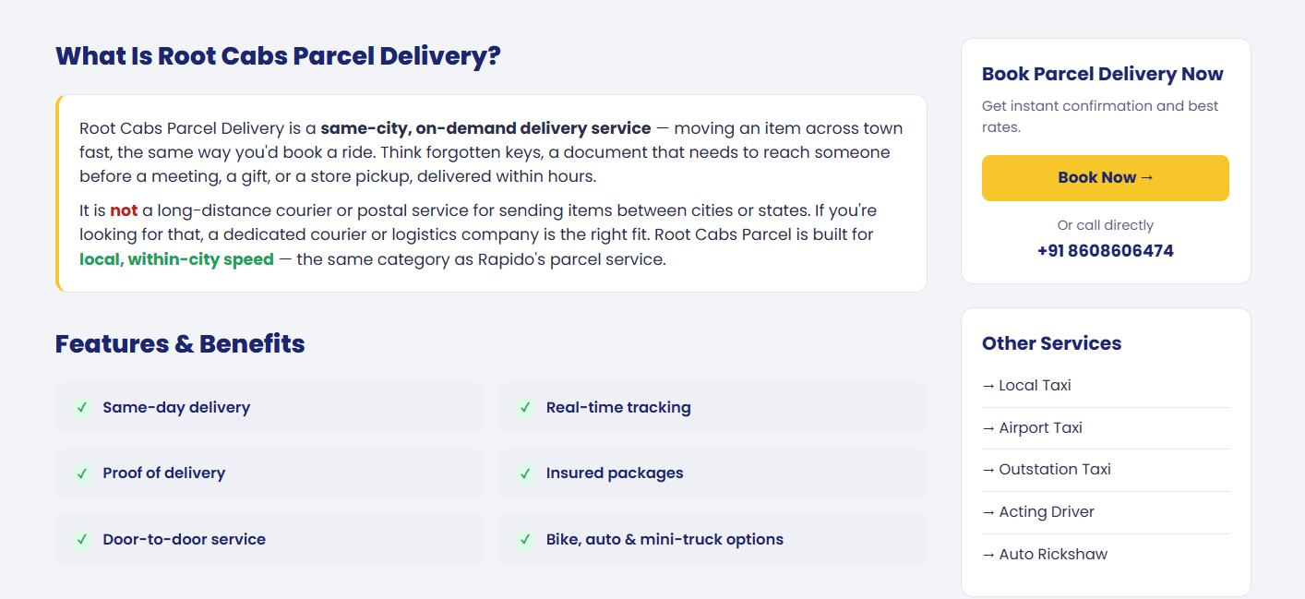

H2 - What You Can Send
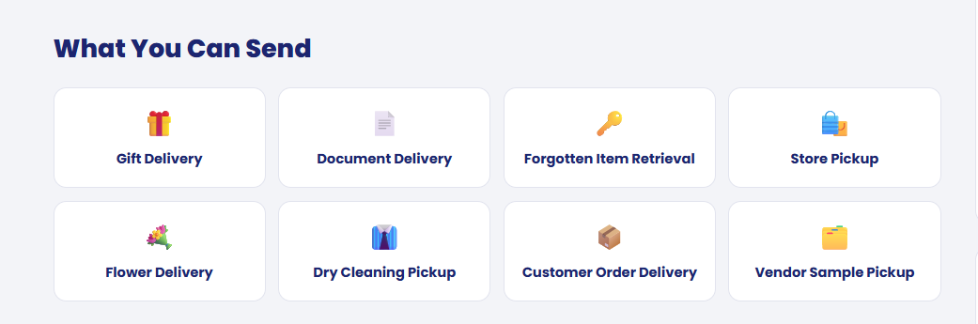

Please add relevant content to this section, including internal links to the Chennai and Vellore pages and other relevant pages where appropriate.

H2 - How It Works

H3 - Enter pickup & drop
H3 - Describe the item
H3 - Driver picks it up
H3 - Track to delivery

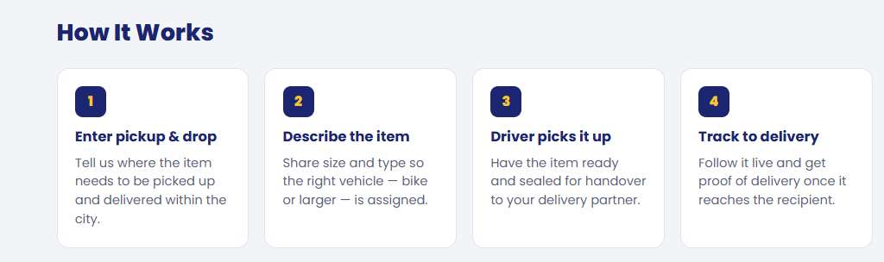

H2 - Parcel Delivery Available In


H2 -

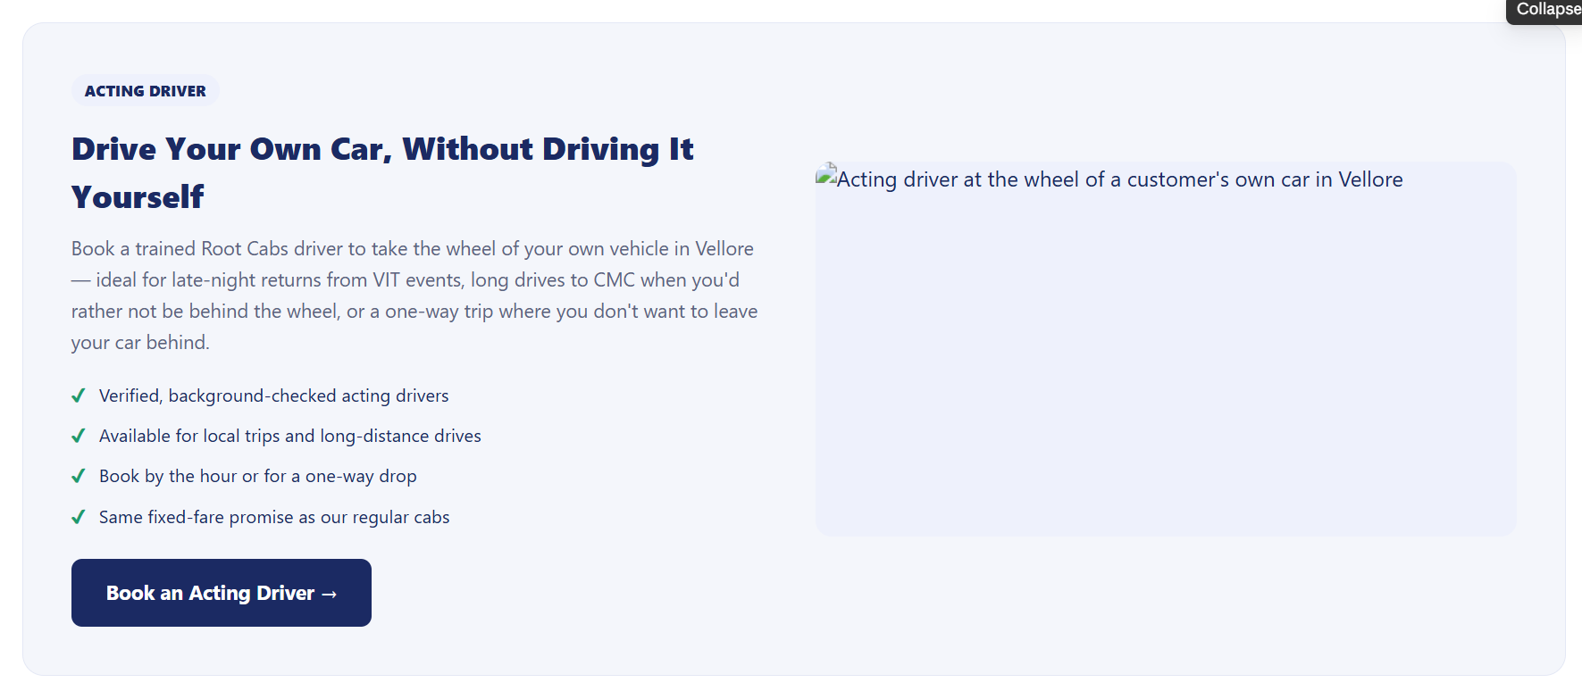

Acting driver section added - Purpose interlinking to the acting driver page.
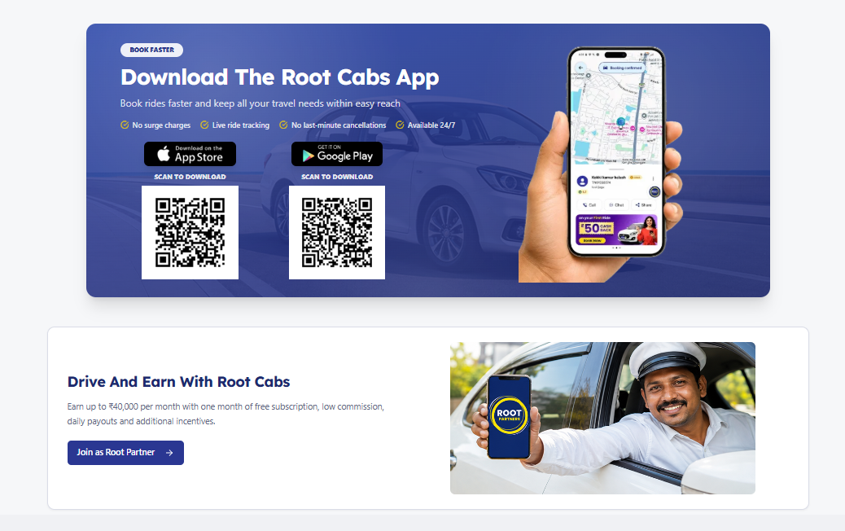

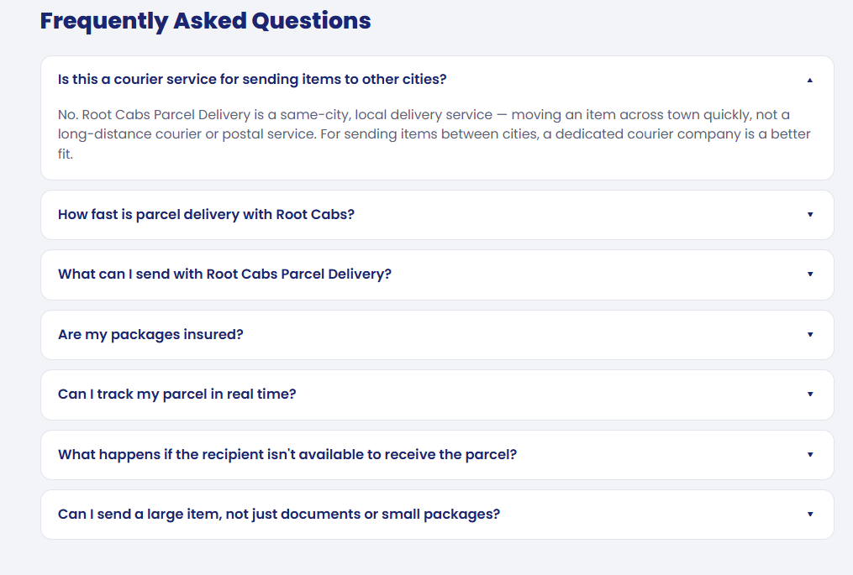
How fast is parcel delivery with Root Cabs?
What can I send with Root Cabs Parcel Delivery?
Are my packages insured?
Can I track my parcel in real time?
Can I send a large item, not just documents or small packages?

